Linux Kernel Patching, Rollback, and Troubleshooting Guide

Process of Linux Server Patching and Step-by-Step Approach

PLANNING & SCHEDULING
- Coordinate with the client or internal team to get the downtime window.
- Raise a Change Request (CR/RFC) using ITIL tools like ServiceNow or Remedy.
- Get CAB approval before proceeding.

PRE-PATCHING CHECKS
I always collect system info and take backups for rollback safety:
- System details: uptime, hostname, uname -a
- File systems: df -h, check /etc/fstab
- Storage info: lsblk, blkid, vgdisplay, lvdisplay
- Network info: ip a, route -n
- Cluster check (if applicable): verify cluster status (PCS/VCS)
- Backup: Confirm latest snapshot/backup before proceeding
- Exclusions: Confirm if any packages should be excluded (e.g., kernel/httpd/DB libs/Java..etc)

EXECUTION (DURING DOWNTIME)
Clean cache and check for updates:
- yum clean all && yum check-update

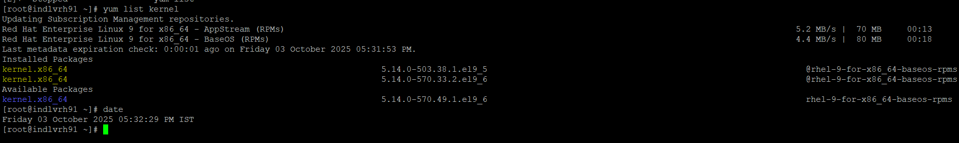

- Apply patches (with exclusions if needed):
- yum update -y

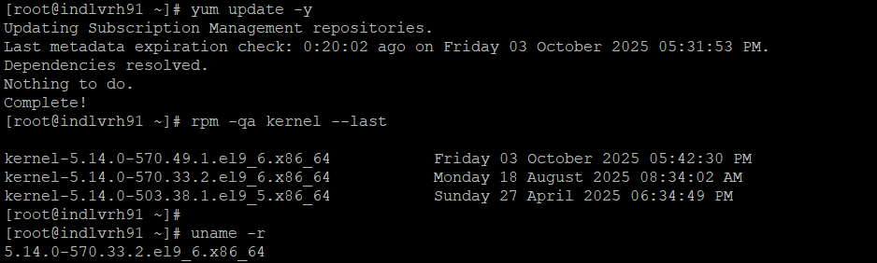

Here I have already performed the patching on this server on October 03,2025.
- #mount -a (Checking FS and FSTAB are mounted properly or not)
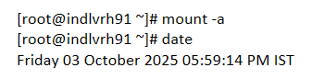
- Reboot the server after updates.

POST-PATCHING VERIFICATION
After reboot, I verify:
- Kernel version: uname -r
- Health checks: top, free -m, df -h
- Service status: Ensure App & DB services are running
- Logs: Review /var/log/messages and dmesg
- Cluster & network: Confirm everything is stable

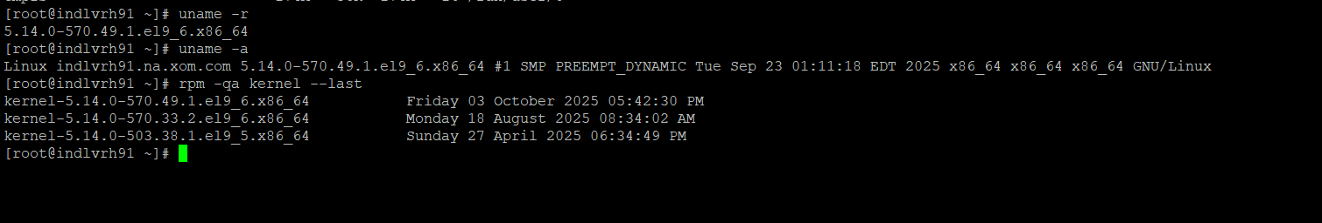
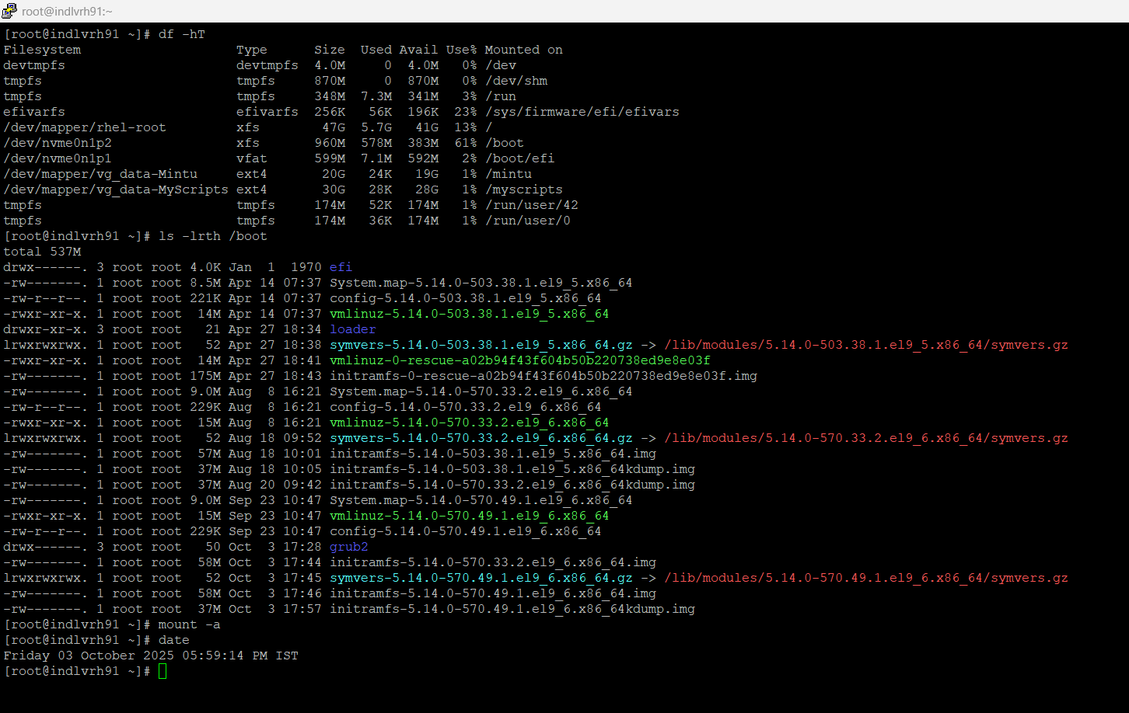

CLOSURE
Once all verification is done, notify the respective teams and update the change record.

Patching Troubleshooting Issues:

- GRUB and Initramfs Recovery
If the system fails to boot after patching (e.g., due to GRUB corruption or broken initramfs), follow these recovery steps.
Scenario
You patched indlvrh91 and, after reboot, you see:
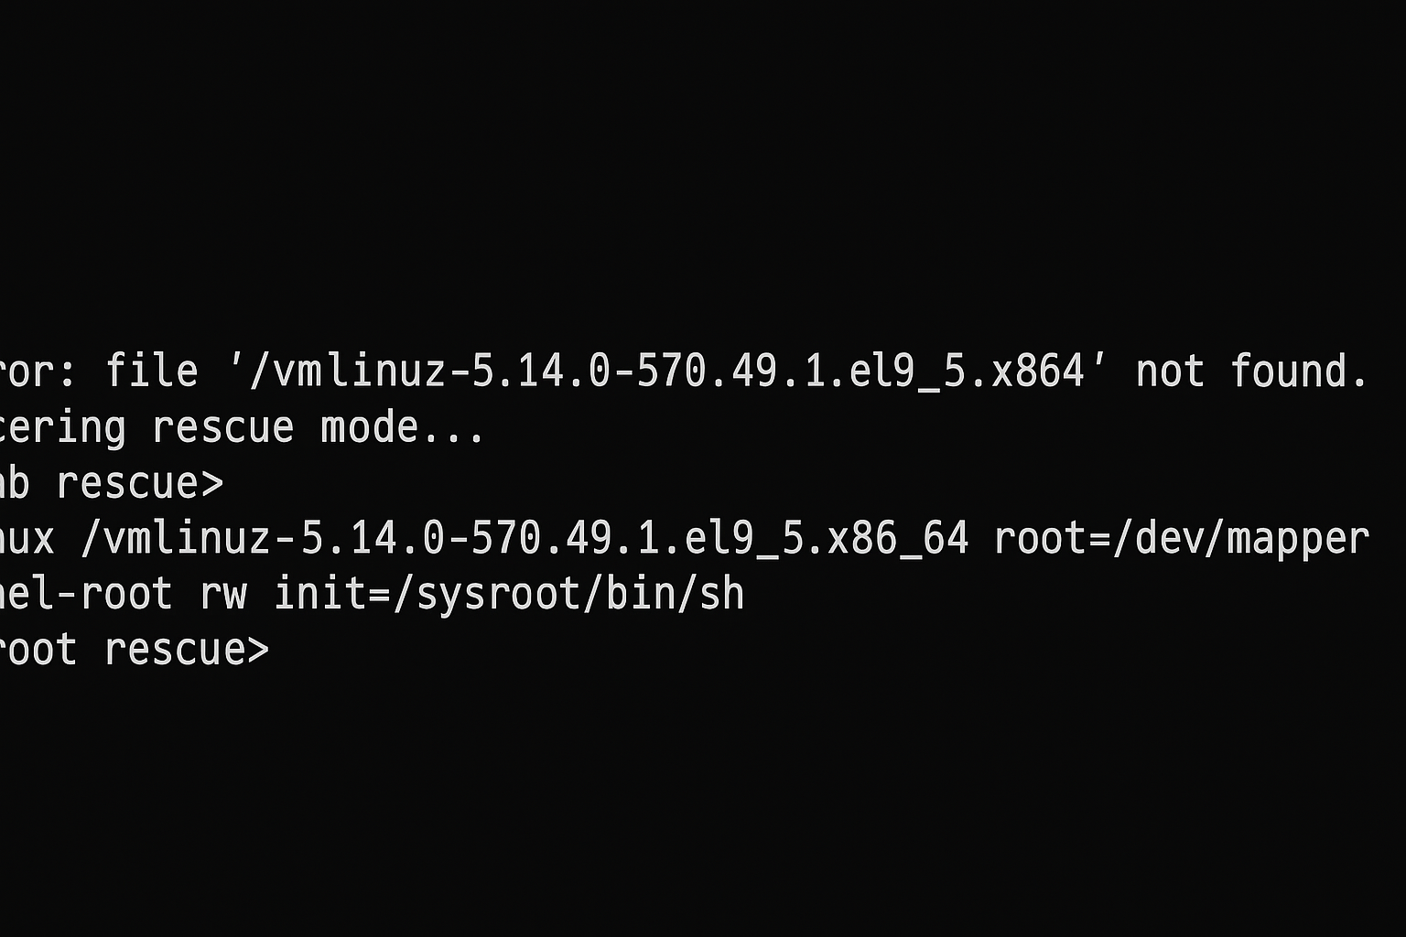
Or
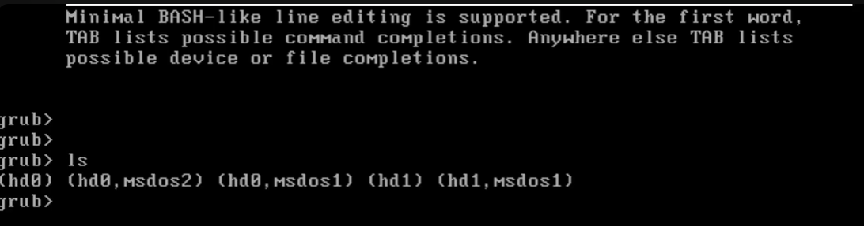
This means either GRUB lost its boot entries or initramfs (initial RAM filesystem) is corrupted.
*Here I have removed grub config file*

Boot into Rescue Mode Using ISO
Insert or mount your RHEL 9 ISO (via console, iLO, or VMware).
Boot from it — the first screen shows:
Install Red Hat Enterprise Linux 9.x
Troubleshooting
Select Troubleshooting → Rescue a Red Hat Enterprise Linux system.
When prompted:
1) Continue
2) Read-only
3) Skip to shell
Choose 1) Continue.
The system mounts your OS root under /mnt/sysimage.

Chroot Into Your Installed System
Switch into your system’s environment:
#chroot /mnt/sysimage
Now all commands act as if you had booted the actual OS.

Example: Rebuild Initramfs
List the current kernels:
#ls /lib/modules
Output:
5.14.0-570.13.1.el9_5.x86_64
5.14.0-570.49.1.el9_5.x86_64
Rebuild the initramfs for the broken kernel:
#dracut -f /boot/initramfs-<kernel-version>.img <kernel-version>
#dracut -f /boot/initramfs-5.14.0-570.49.1.el9_5.x86_64.img 5.14.0-570.49.1.el9_5.x86_64
You’ll see output confirming a new initramfs image is generated.
Verify: #ls -lh /boot/initramfs-5.14.0-570.49.1.el9_5.x86_64.img

Reinstall GRUB (if corrupted)
Identify your boot disk: #lsblk
Suppose it’s /dev/sda.
Then reinstall GRUB: #grub2-install /dev/sda
Recreate the GRUB menu: #grub2-mkconfig -o /boot/grub2/grub.cfg
Expected output:
Found linux image: /boot/vmlinuz-5.14.0-570.49.1.el9_5.x86_64
Found initrd image: /boot/initramfs-5.14.0-570.49.1.el9_5.x86_64.img
Done
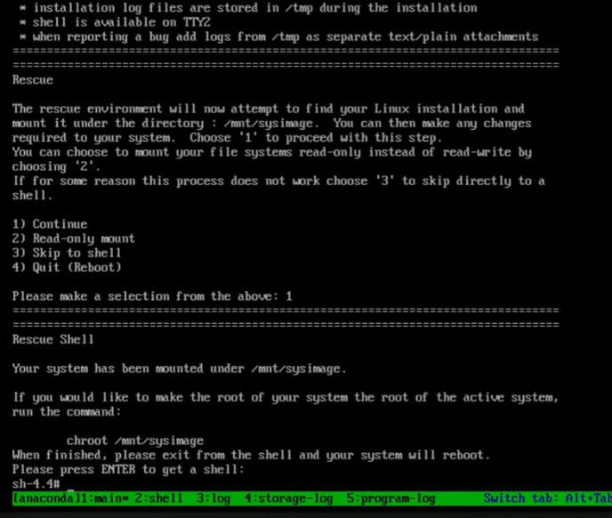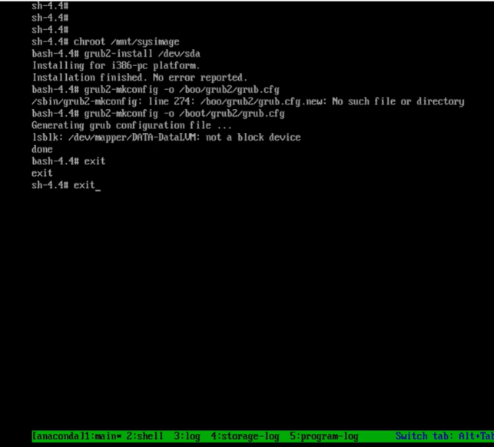

Exit Rescue Mode and Reboot
#exit
#reboot
When the server restarts, it should boot normally into:
Red Hat Enterprise Linux (5.14.0-570.49.1.el9_5.x86_64)
Check the running kernel: #uname -r
Output: 5.14.0-570.49.1.el9_5.x86_64
Recovery successful!

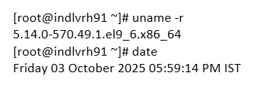

- Kernel Rollback Options
If the new kernel causes system issues, use one of the following rollback options.

Option 1: Manual Recovery via GRUB (Single-User Mode)
Used when the server fails to boot or root password recovery or repair is needed.
Steps
- Reboot and access the GRUB menu.
- Highlight the previous stable kernel, e.g.:Red Hat Enterprise Linux (5.14.0-570.13.1.el9_5.x86_64)
- Press e to edit boot parameters.
- Find the line starting with linux and modify:
  - Replace ro with rw init=/sysroot/bin/sh
  - Example:
  - linux /vmlinuz-5.14.0-570.13.1.el9_5.x86_64 root=/dev/mapper/rhel-root rw init=/sysroot/bin/sh
- Press Ctrl + X to boot into single-user mode.
At the prompt, run:
- mount -o remount,rw /sysroot
- chroot /sysroot
- passwd
- touch /.autorelabel
- exit
- reboot
- System reboots, SELinux relabels automatically.
Verify: #uname -r
Output example: 5.14.0-570.13.1.el9_5.x86_64

Next Steps
Once the system is up:
- Re-patch the kernel if issue was transient:
- yum clean all
- yum update -y kernel
- reboot
- Or rollback using YUM if new kernel remains unstable.

Option 2: Rollback Using YUM History (Recommended)

YUM maintains a log of all transactions — this allows a clean rollback of kernel patches.
Check YUM History: #yum history
Example:
ID | Command | Date and time | Action(s) | Altered
-------------------------------------------------------------
45 | update | 2025-10-03 17:35 | Update | 12
Review Transaction Details : #yum history info 45
Undo Kernel Patch: #yum history undo 45 -y
This command:
- Removes the new kernel
- Restores the previous version
- Reverts any other packages updated in that transaction
5.2.4 Verify Rollback
#rpm -qa kernel –last, #uname -r
The server should now be running the previous, stable kernel.

Validation Checks After Recovery or Rollback

Check | Command | Expected Result
Current kernel version | uname -r | Correct version displayed
Boot entries | grep menuentry /boot/grub2/grub.cfg | Both old and new kernels listed
Boot partition usage | df -h /boot | Sufficient free space
Initramfs presence | ls /boot/initramfs-* | Images exist for all kernels
GRUB configuration | cat /etc/default/grub | Default entry is correct

Best Practices
- Keep at least two kernel versions installed for safety.
- Always back up /boot before applying patches.
- Ensure SELinux relabeling after single-user mode repairs.
- Document YUM transaction IDs for traceability.
- Validate critical services and mount points after reboot.
- Schedule patching during maintenance windows.

Summary Table

Action | Command | Description
List kernels | rpm -qa kernel --last | Show installed kernel versions
Apply kernel patch | yum update -y | Install latest kernel
Rebuild initramfs | dracut -f | Fix corrupted initramfs
Reinstall GRUB | grub2-install /dev/sda | Restore GRUB bootloader
GRUB rollback | (Manual via single-user) | Boot from old kernel manually
YUM rollback | yum history undo <ID> | Revert kernel update cleanly
Verify kernel | uname -r | Confirm active kernel
Backup /boot | cp -a /boot /boot_backup_$(date +%F) | Safe snapshot before patching

10. Conclusion
The Linux kernel patching process must be handled with care to maintain system uptime and recoverability.
Following this guide ensures:
- Proper patching and verification
- Reliable rollback using YUM or GRUB
- Recovery from GRUB/initramfs corruption
- Full compliance with enterprise patching best practices
Document Completed: Linux Kernel Patching, Rollback, and Troubleshooting Guide
System Stable: Verified post-patch
Rollback Procedure: Tested and validateds

